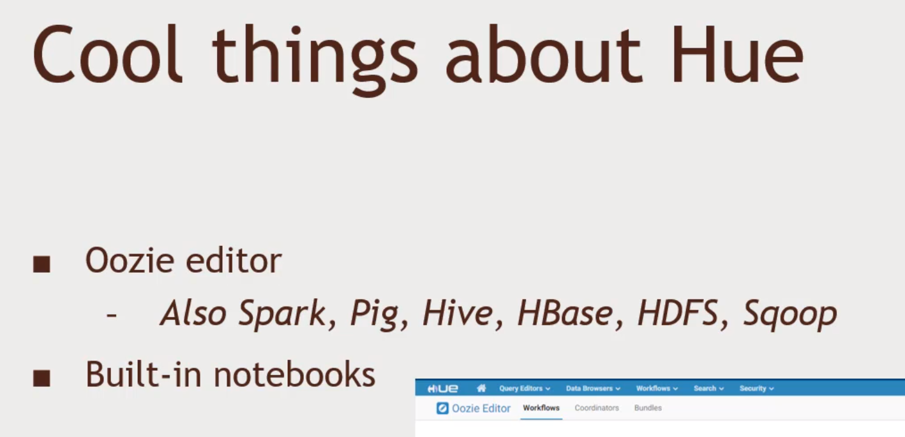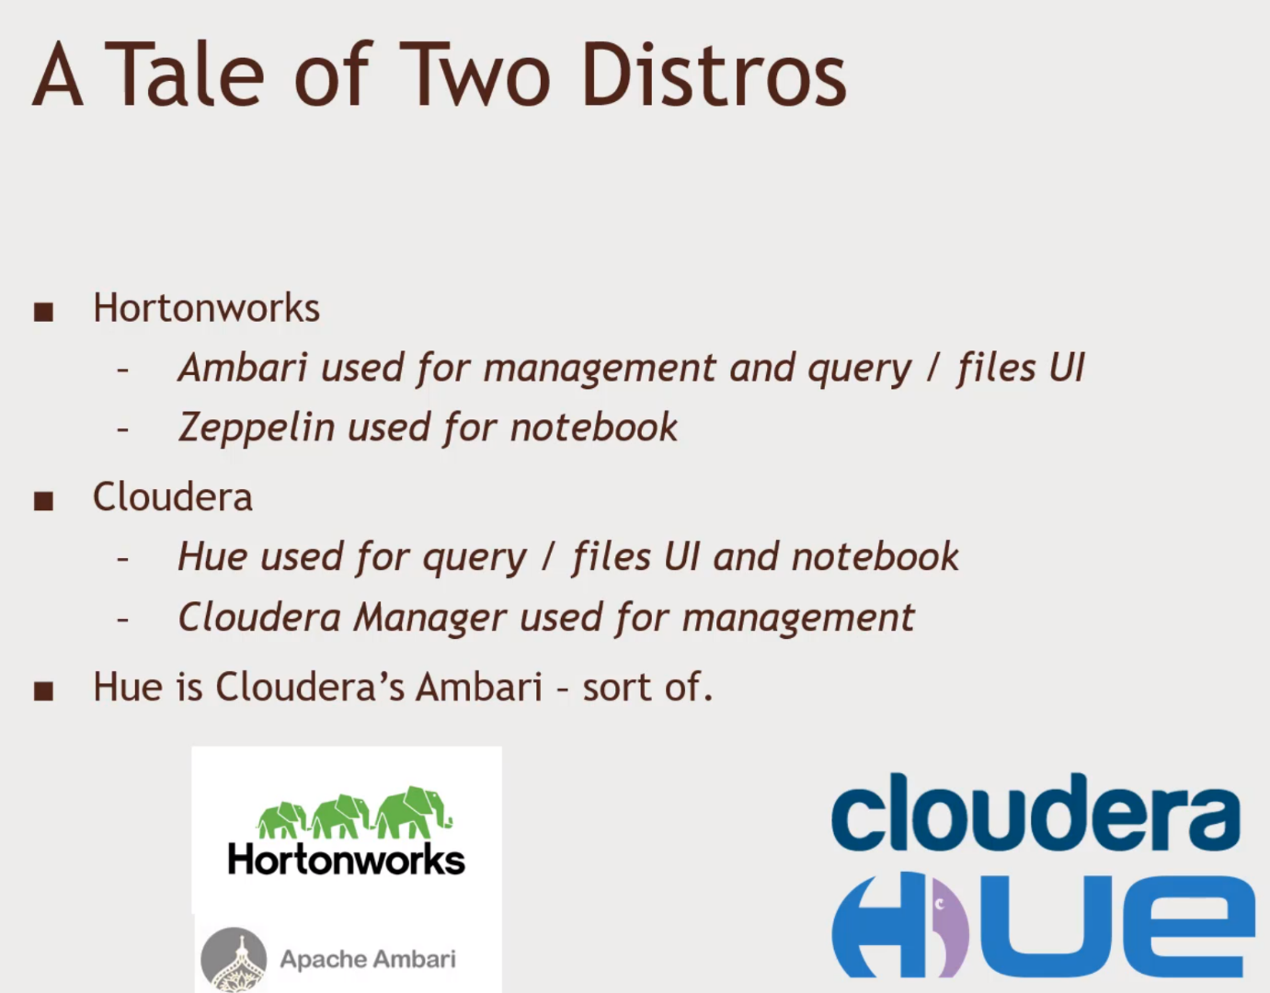Hadoop User Experience HUE.

Hue is Open source

* Not an apache project; maintained by Cloudera
* It can be iinstalled on a HortonsWorks Distribution
* There is a live demo on the web browser.
* gethue.com and play around for a bit. There is Hive Editors and all.

Coordinators schedules the tasks, bundles are a collection of coordinators.

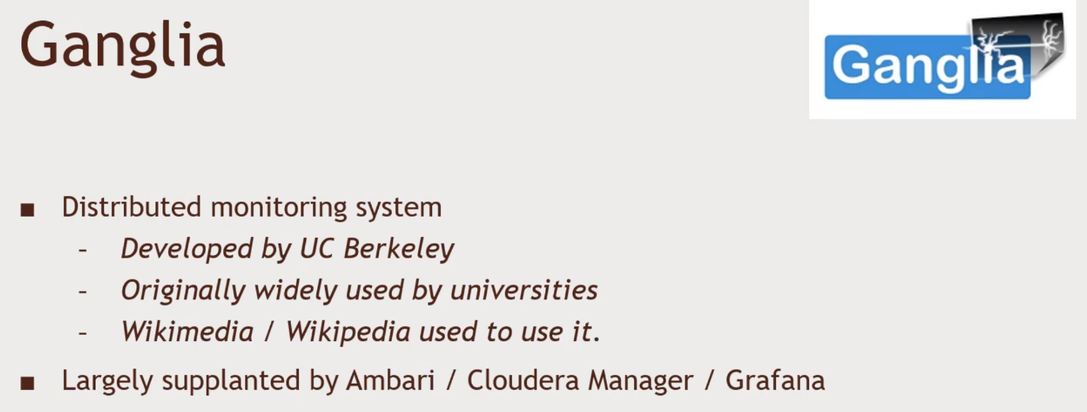 Monitor your Clusters and Operational Details. But it looks a bit ghetto. Graphana,

Last updated in 2008. Website is largely broken, might encounter it in really old systems.

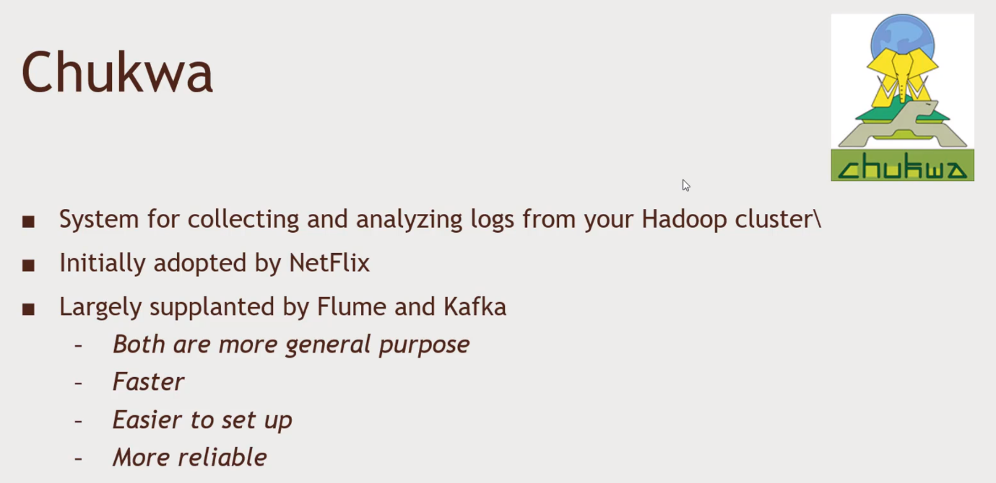Dead, Hasn’t changed since 2010. No usage to speak of today.